1. **Field Access**: When you want to debug where the field value is being changed or/and accessed.
2. 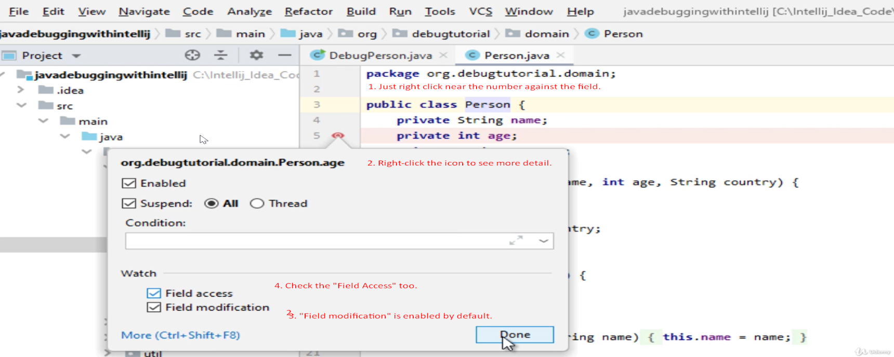
3. 